**Log In Application**

**Homework 1**

1. Overview
2. Specifications
3. Perquisites
4. Documentation
   1. Creating an account
   2. Sign in
   3. Manage Profile
   4. Known Bugs
5. Tests
   1. Test 1-Sign Up
   2. Test 2- Sign In
   3. Test 3 - Profile
6. Functions
   1. Sign In
   2. Sign Up
   3. Profile
7. Appendix 1
8. **Overview**

The purpose of this assignment was to build a simple *Log in* application for mobile devices. The two major platforms on the market, nowadays, are Android and iOS.

Android, is the world's most popular mobile platform, powers hundreds of millions of mobile devices in more than 190 countries around the world. It's the largest installed base of any mobile platform and growing fast—every day another million users power up their Android devices for the first time and start looking for apps, games, and other digital content. That’s why we chose **Android SDK** todevelop our application**.**

The application was built using the **Eclipse IDE**, with the **ADT plug-in** for **Android SDK**.

1. **Specifications**
   1. The application will display a Log In interface
   2. The user will be able to log in, or create an account
   3. As an authenticated user, one can create and modify the profile, with the data being saved in a database
   4. An authenticated user can change the password
2. **Perquisites**
   1. A device with at least Android 2.3.1 (Froyo)
   2. The device must have an internet connection
   3. The application is target for the Android 4.0.4, API Level 15
   4. 1 MB of free space
3. **Documentation**
   1. **Creating an account**

Launch the application on your phone and choose **Sign Up** from the menu (Fig1). A new activity will appear where you can fill your information (Fig2). Press **Sign Up** again to create the account. If everything was right, a message will be prompted and the application will return to the **Log In** activity (Fig1).

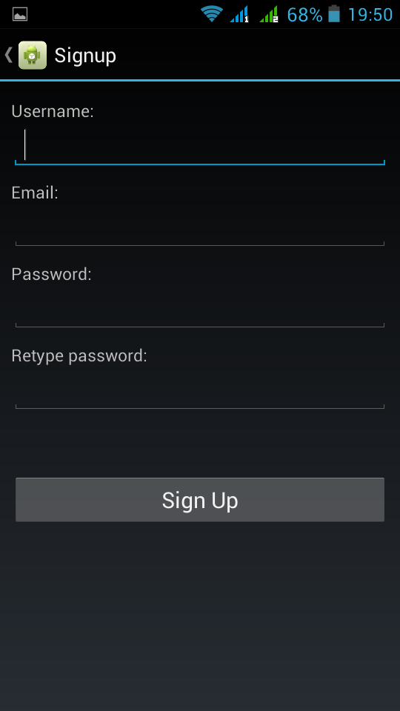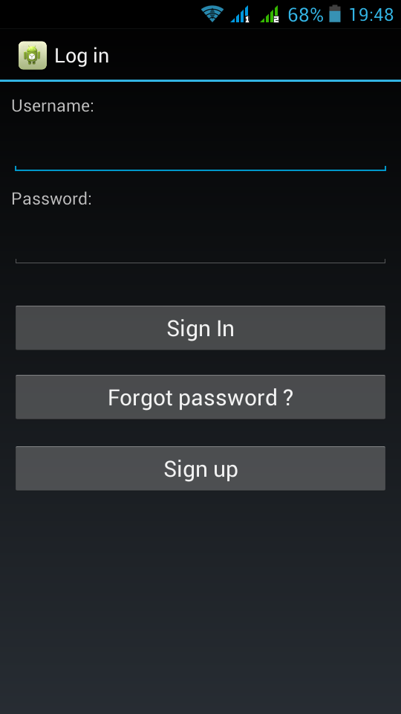

`

**(Fig 1) (Fig 2)**

* 1. **Sign In**

If you already have an account, fill in the username and the password in the **Log In** activity (Fig 1).

* 1. **Manage Profile**

After successfully signing into the application you will be redirected to your **Profile** (Fig 3). If you have a new account, most of the fields will be empty. You can complete your profile by filling into the text views for each field, or by choosing from the list boxes. Then, hit the **Save** button at the end in order to save your data. **Caution:** The updates will not be saved after you close the application without pressing **Save** button.

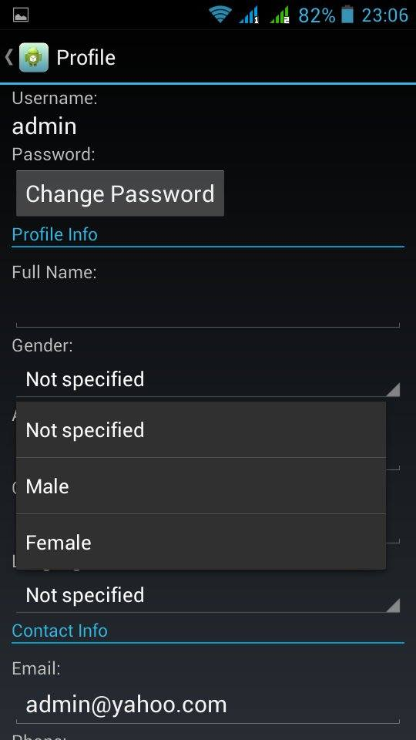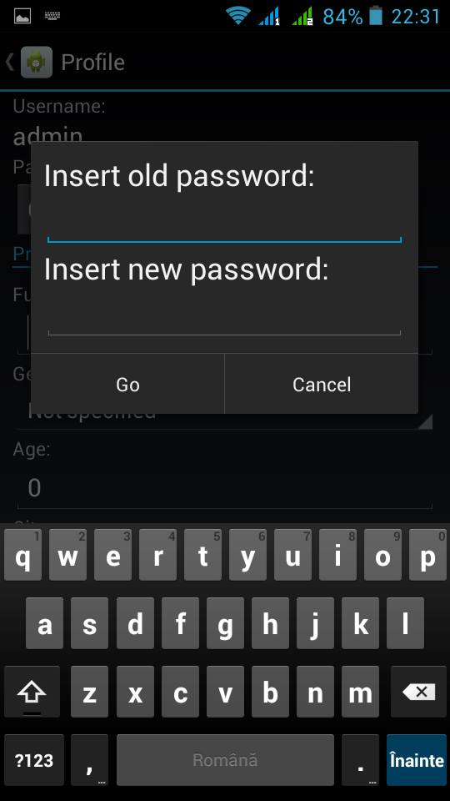

(Fig 3) (Fig 4)

In order to change, your password hit the **Change Password** button. A dialog will appear, as in (Fig 4). Introduce your old password and your new password and hit OK. It is not required to hit **Save** after this operation**.**

1. **Tests** 
   1. **Test 1 – Sign up**

A number of constraints have been applied to ensure the data validation.

If the user tries to register with an empty field user name, password or email, a message will be prompted and the account won’t be created (Fig 5).

To avoid any mistyping error in the password field, it has to be introduced twice. If there is any difference, the account won’t be created and a message will be prompted (Fig 6).

To ensure, the singularity of the username, the database is checked before. If there is another account with the same username, the account won’t be created (Fig 7).

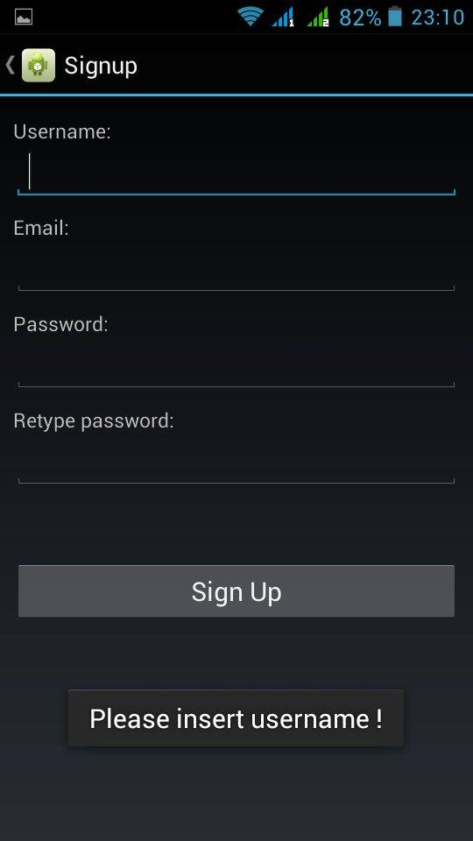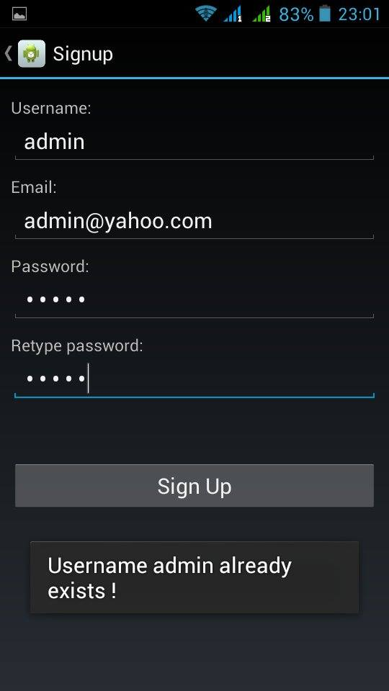

(Fig 5) (Fig 6)

* 1. **Test 2 – Sign in**

If you try to log in with an empty field, password or username, a message will be displayed.

If the username or the password doesn’t match any recording in the database, then a message like in (Fig 8) will be displayed.

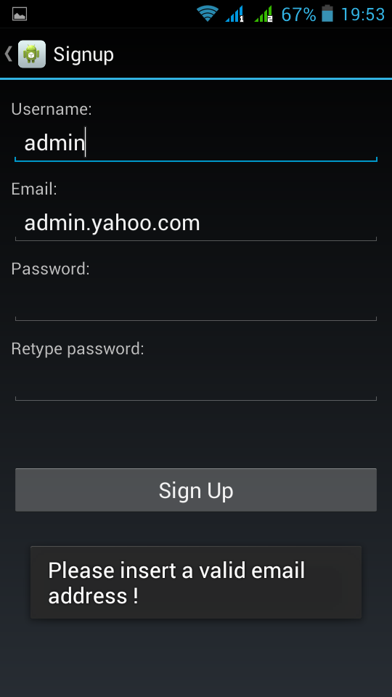

(Fig 8)

**c.** **Test 3- Profile**

The user can insert the into the Profile view, and save by hitting the save button. No email validation has been implemented yet. The password can be changed from the Dialog in (Fig 4). The old password is checked to correspond to the one in the database.

1. **Known Bugs**
   * 1. No data will be saved if suddenly the internet connection fails, no data saved locally
     2. No email validation in the Profile activity(not implemented yet)
     3. Forget Password button is not implemented yet
2. **Functions** 
   1. **Sign in Activity(LoginActivity.java) - Functions**

**void onCreate() method :**

* is called when the application is launched. The user interface is built here based on the corresponding XML file
* the connection with the parse.com database is created here
* controls are connected to the widgets in the interface

**void signin() method:**

* + - called by clicking on the **Sign In** button
    - checks the data inserted and looks for the user in the database
    - if the data is valid launches the Profile Acitivity sending the username via an Intent

**void signup() method:**

* + - called by clicking on the **Sign Up** button
    - opens the Sign Up Activity

See full code with comments in Appendix 1.

* 1. **Sign Up Activity(SignupActivity.java) - Functions**

**void onCreate() method :**

* is called when the application is launched. The user interface is built here based on the corresponding XML file
* the connection with the parse.com database is created here
* controls are connected to the widgets in the interface

**void signup() method:**

* + - called by clicking on the **Sign Up** button
    - validates the data inserted into the fields
    - performs regular expression validation on the email
    - checks for the existence of the introduced username
    - creates a new account and saves it in the database

See full code with comments in Appendix 1.

* 1. **Profile Activity(ProfileActivity.java) - Functions**

**void onCreate() method :**

* is called when the application is launched. The user interface is built here based on the corresponding XML file
* the connection with the parse.com database is created here
* gets the username sent by the **Sign In** activity via intent
* queries the database for the given username’
* controls are connected to the widgets in the interface
* updates the fields with the information from the database

**void popDialog() method:**

* + - called by clicking on the **Change Password** button
    - opens an AlertDialog with two fields for old an new password
    - queries the table for the old password to compare it to the inserted one
    - updates the new password(no empty field allowed)

**void saveData() method:**

* + - called by clicking on the **Save** button
    - updates the database for each field with the values inserted by the user
    - return to Sign In acitivity

See full code with comments in Appendix 1.

1. **Appendix 1**

**LoginActivity.java**

package com**.**example**.**md_hw1**;**

**import** java**.**util**.**List**;**

**import** com**.**parse**.**FindCallback**;**

**import** com**.**parse**.**Parse**;**

**import** com**.**parse**.**ParseAnalytics**;**

**import** com**.**parse**.**ParseObject**;**

**import** com**.**parse**.**ParseQuery**;**

**import** com**.**parse**.**PushService**;**

**import** com**.**parse**.**ParseException**;**

**import** android**.**app**.**Activity**;**

**import** android**.**content**.**Intent**;**

**import** android**.**os**.**Bundle**;**

**import** android**.**view**.**View**;**

**import** android**.**widget**.**EditText**;**

**import** android**.**widget**.**Toast**;**

public class LoginActivity **extends** Activity **{**

private EditText usernameEdit**;**

private EditText passwordEdit**;**

private final String USER_TABLE **=**"Profiles"**;**

public final static String EXTRA_MESSAGE **=** "com.example.myfirstapp.MESSAGE"**;**

private String message**;**

@Override

protected void onCreate**(**Bundle savedInstanceState**)** **{**

**super.**onCreate**(**savedInstanceState**);**

setContentView**(**R**.**layout**.**activity_login**);**

//The arguments are the APP_ID, and the CLient_ID from parse.com

Parse**.**initialize**(this,** "udumMDhauwhzIXHbWK1Bm3twUIP63F4y2Eq1BGVO"**,** "FXKoOICrczFFrYLMMvn6qRg3bB4rLCkzKdkS1qOU"**);**

ParseAnalytics**.**trackAppOpened**(**getIntent**());**

//Get username and password editText from layout

usernameEdit**=(**EditText**)**findViewById**(**R**.**id**.**usernameEdit**);**

passwordEdit**=(**EditText**)**findViewById**(**R**.**id**.**passwordEdit**);**

**}**

public void signin**(**View view**){**

//Fetch the username and password from the edittext

String username**=**usernameEdit**.**getText**().**toString**();**

String password**=**passwordEdit**.**getText**().**toString**();**

**if(**username**.**length**()==**0**)**

Toast**.**makeText**(**getApplicationContext**(),** "Please insert username !"**,** Toast**.**LENGTH_SHORT**).**show**();**

**else**

**if(**password**.**length**()==**0**)**

Toast**.**makeText**(**getApplicationContext**(),** "Please insert password !"**,** Toast**.**LENGTH_SHORT**).**show**();**

**else**

**{**

//Initiate a parse query

ParseQuery**<**ParseObject**>** query **=** ParseQuery**.**getQuery**(**USER_TABLE**);**

//Select where username is @username and password is @password

query**.**whereEqualTo**(**"username"**,** username**);**

query**.**whereEqualTo**(**"password"**,** password**);**

//make the query

**try{**

List**<**ParseObject**>** userList**=**query**.**find**();**

//if the username was found open Profile activity

**if(**userList**.**size**()>**0**)**

**{**

message**=**username**;**

Toast**.**makeText**(**getApplicationContext**(),**"Redirecting..."**,** Toast**.**LENGTH_SHORT**).**show**();**

Intent intent **=** **new** Intent**(this,** Profile**.**class**);**

//send the user name via intent to be used in profile acitivity

intent**.**putExtra**(**EXTRA_MESSAGE**,** message**);**

startActivity**(**intent**);**

**}**

**else**

Toast**.**makeText**(**getApplicationContext**(),** "Invalid username/password !"**,** Toast**.**LENGTH_SHORT**).**show**();**

**}**

**catch(**ParseException e**){**

Toast**.**makeText**(**getApplicationContext**(),** e**.**getMessage**(),** Toast**.**LENGTH_LONG**).**show**();**

**}**

**}**

passwordEdit**.**setText**(**""**);**

**}**

public void signup**(**View view**){**

//start the signup activity

Intent intent **=** **new** Intent**(this,** Signup**.**class**);**

**this.**startActivity**(**intent**);**

**}**

**}**

**Signup.java**

package com**.**example**.**md_hw1**;**

**import** java**.**util**.**ArrayList**;**

**import** java**.**util**.**List**;**

**import** com**.**parse**.**FindCallback**;**

**import** com**.**parse**.**Parse**;**

**import** com**.**parse**.**ParseAnalytics**;**

**import** com**.**parse**.**ParseException**;**

**import** com**.**parse**.**ParseObject**;**

**import** com**.**parse**.**ParseQuery**;**

**import** android**.**app**.**Activity**;**

**import** android**.**os**.**Bundle**;**

**import** android**.**view**.**Menu**;**

**import** android**.**view**.**MenuItem**;**

**import** android**.**view**.**View**;**

**import** android**.**widget**.**EditText**;**

**import** android**.**widget**.**Toast**;**

**import** java**.**util**.**regex**.**Matcher**;**

**import** java**.**util**.**regex**.**Pattern**;**

public class Signup **extends** Activity **{**

private EditText usernameEdit**;**

private EditText passwordEdit**;**

private EditText repasswordEdit**;**

private EditText emailEdit**;**

private final String USER_TABLE **=**"Profiles"**;**

private String username**,**password**,**email**;**

//regular expression pattern for email validation

private static final String EMAIL_PATTERN **=**

"^[_A-Za-z0-9-\\+]+(\\.[_A-Za-z0-9-]+)*@"

**+** "[A-Za-z0-9-]+(\\.[A-Za-z0-9]+)*(\\.[A-Za-z]{2,})$"**;**

private ParseObject users**,**contacts**,**profiles**;** //the object handles the table users

private Pattern pattern**;**

private Matcher matcher**;**

@Override

protected void onCreate**(**Bundle savedInstanceState**)** **{**

**super.**onCreate**(**savedInstanceState**);**

setContentView**(**R**.**layout**.**activity_signup**);**

//Initialize PARSE

//The arguments are the APP_ID, and the CLient_ID from parse.com

Parse**.**initialize**(this,** "udumMDhauwhzIXHbWK1Bm3twUIP63F4y2Eq1BGVO"**,** "FXKoOICrczFFrYLMMvn6qRg3bB4rLCkzKdkS1qOU"**);**

ParseAnalytics**.**trackAppOpened**(**getIntent**());**

//Create a new ParseObject that will handle the users table

users **=** **new** ParseObject**(**USER_TABLE**);**

//Get username and password editText from layout

usernameEdit**=(**EditText**)**findViewById**(**R**.**id**.**username**);**

passwordEdit**=(**EditText**)**findViewById**(**R**.**id**.**password**);**

repasswordEdit**=(**EditText**)**findViewById**(**R**.**id**.**repassword**);**

emailEdit**=(**EditText**)**findViewById**(**R**.**id**.**email**);**

//Regular expression email validator

pattern **=** Pattern**.**compile**(**EMAIL_PATTERN**);**

**}**

public void signup**(**View view**){**

//Fetch the username and password from the edittext

username**=**usernameEdit**.**getText**().**toString**();**

password**=**passwordEdit**.**getText**().**toString**();**

email**=**emailEdit**.**getText**().**toString**();**

**if(**username**.**length**()==**0**)**

Toast**.**makeText**(**getApplicationContext**(),** "Please insert username !"**,** Toast**.**LENGTH_LONG**).**show**();**

//if it DOES NOT validates the reg expression for email

**if(**pattern**.**matcher**(**email**).**matches**()==false)**

Toast**.**makeText**(**getApplicationContext**(),** "Please insert a valid email address !"**,** Toast**.**LENGTH_LONG**).**show**();**

**else**

**if(**password**.**length**()==**0**)**

Toast**.**makeText**(**getApplicationContext**(),** "Please insert password !"**,** Toast**.**LENGTH_LONG**).**show**();**

**else**

**if(!**password**.**equals**(**repasswordEdit**.**getText**().**toString**()))**

Toast**.**makeText**(**getApplicationContext**(),** "Passwords are not the same"**,** Toast**.**LENGTH_LONG**).**show**();**

**else**

**{**

//Make a query to check wether the user already exists

ParseQuery**<**ParseObject**>** query **=** ParseQuery**.**getQuery**(**USER_TABLE**);**

//Select where username is @username

query**.**whereEqualTo**(**"username"**,**username**);**

query**.**findInBackground**(new** FindCallback**<**ParseObject**>()** **{**

public void done**(**List**<**ParseObject**>** userList**,** ParseException e**)** **{**

**if** **(**e **==** **null)** **{**

**if(**userList**.**size**()>**0**)**

Toast**.**makeText**(**getApplicationContext**(),** "Username "**+**username**+**" already exists !"**,** Toast**.**LENGTH_LONG**).**show**();**

**else**

**{**

Toast**.**makeText**(**getApplicationContext**(),** "Account created !"**,** Toast**.**LENGTH_SHORT**).**show**();**

users**.**put**(**"username"**,** username**);**

users**.**put**(**"password"**,** password**);**

users**.**put**(**"username"**,**username**);**

users**.**put**(**"Email"**,**email**);**

users**.**saveInBackground**();**

finish**();**

**}**

**}** **else** **{**

Toast**.**makeText**(**getApplicationContext**(),** e**.**getMessage**(),** Toast**.**LENGTH_SHORT**).**show**();**

**}**

**}**

**});**

**}**

**}**

**}**

**Profile.java**

package com**.**example**.**md_hw1**;**

**import** java**.**util**.**List**;**

**import** com**.**parse**.**Parse**;**

**import** com**.**parse**.**ParseAnalytics**;**

**import** com**.**parse**.**ParseException**;**

**import** com**.**parse**.**ParseObject**;**

**import** com**.**parse**.**ParseQuery**;**

**import** android**.**app**.**Activity**;**

**import** android**.**app**.**AlertDialog**;**

**import** android**.**content**.**DialogInterface**;**

**import** android**.**content**.**Intent**;**

**import** android**.**os**.**Bundle**;**

**import** android**.**view**.**LayoutInflater**;**

**import** android**.**view**.**Menu**;**

**import** android**.**view**.**MenuItem**;**

**import** android**.**view**.**View**;**

**import** android**.**widget**.**AdapterView**;**

**import** android**.**widget**.**AdapterView**.**OnItemSelectedListener**;**

**import** android**.**widget**.**ArrayAdapter**;**

**import** android**.**widget**.**EditText**;**

**import** android**.**widget**.**Spinner**;**

**import** android**.**widget**.**TextView**;**

**import** android**.**widget**.**Toast**;**

public class Profile **extends** Activity **{**

private TextView usernameView**,**fullnameView**,**ageView**,**cityView**,**emailView**,**phoneView**,**passwordView**;**

private Spinner genderView**,**languageView**;**

private final String USERS_TABLE **=**"Profiles"**;**

private String ID**,**password**;**

private ParseObject user**;**

@Override

protected void onCreate**(**Bundle savedInstanceState**)** **{**

**super.**onCreate**(**savedInstanceState**);**

setContentView**(**R**.**layout**.**activity_profile**);**

//The arguments are the APP_ID, and the CLient_ID from parse.com

Parse**.**initialize**(this,** "udumMDhauwhzIXHbWK1Bm3twUIP63F4y2Eq1BGVO"**,** "FXKoOICrczFFrYLMMvn6qRg3bB4rLCkzKdkS1qOU"**);**

//Get textviews and spinners

genderView **=** **(**Spinner**)** findViewById**(**R**.**id**.**gender**);**

// Create an ArrayAdapter using the string array and a default spinner layout

ArrayAdapter**<**CharSequence**>** adapter **=** ArrayAdapter**.**createFromResource**(this,**

R**.**array**.**genders**,** android**.**R**.**layout**.**simple_spinner_item**);**

// Specify the layout to use when the list of choices appears

adapter**.**setDropDownViewResource**(**android**.**R**.**layout**.**simple_spinner_dropdown_item**);**

// Apply the adapter to the spinner

genderView**.**setAdapter**(**adapter**);**

//Init language spinner

languageView**=(**Spinner**)**findViewById**(**R**.**id**.**language**);**

ArrayAdapter**<**CharSequence**>** ladapter**=**ArrayAdapter**.**createFromResource**(this,**

R**.**array**.**languages**,** android**.**R**.**layout**.**simple_spinner_item**);**

// Specify the layout to use when the list of choices appears

ladapter**.**setDropDownViewResource**(**android**.**R**.**layout**.**simple_spinner_dropdown_item**);**

// Apply the adapter to the spinner

languageView**.**setAdapter**(**ladapter**);**

usernameView**=(**TextView**)**findViewById**(**R**.**id**.**username**);**

fullnameView**=(**TextView**)**findViewById**(**R**.**id**.**fullname**);**

passwordView**=(**TextView**)**findViewById**(**R**.**id**.**password**);**

ageView**=(**TextView**)**findViewById**(**R**.**id**.**age**);**

cityView**=(**TextView**)**findViewById**(**R**.**id**.**city**);**

emailView**=(**TextView**)**findViewById**(**R**.**id**.**email**);**

phoneView**=(**TextView**)**findViewById**(**R**.**id**.**phone**);**

// Get the message from the intent

Intent intent **=** getIntent**();**

String username **=** intent**.**getStringExtra**(**LoginActivity**.**EXTRA_MESSAGE**);**

//Query the database for the rest of the information

ParseQuery**<**ParseObject**>** query **=** ParseQuery**.**getQuery**(**USERS_TABLE**);**

//Select where username is @username and password is @password

query**.**whereEqualTo**(**"username"**,** username**);**

**try{**

List**<**ParseObject**>** userList**=**query**.**find**();**

//Fetch the data from the database into the fields on the acitivty

ParseObject user**=**userList**.**get**(**0**);**

ID**=**user**.**getObjectId**();**

usernameView**.**setText**(**user**.**getString**(**"username"**));**

password**=**user**.**getString**(**"password"**);**

fullnameView**.**setText**(**user**.**getString**(**"fullname"**));**

genderView**.**setSelection**(**user**.**getInt**(**"Gender"**));**

ageView**.**setText**(**Integer**.**toString**(**user**.**getInt**(**"Age"**)));**

cityView**.**setText**(**user**.**getString**(**"City"**));**

languageView**.**setSelection**(**user**.**getInt**(**"Language"**));**

emailView**.**setText**(**user**.**getString**(**"Email"**));**

phoneView**.**setText**(**user**.**getString**(**"Phone"**));**

**}**

**catch(**ParseException e**){**

Toast**.**makeText**(**getApplicationContext**(),** e**.**getMessage**(),** Toast**.**LENGTH_LONG**).**show**();**

**}**

**}**

public void popDialog**(**View view**){**

// get prompts.xml view

user **=** ParseObject**.**createWithoutData**(**USERS_TABLE**,** ID**);**

LayoutInflater li **=** LayoutInflater**.**from**(this);**

View promptsView **=** li**.**inflate**(**R**.**layout**.**password**,** **null);**

final AlertDialog**.**Builder alertDialogBuilder **=** **new** AlertDialog**.**Builder**(this);**

alertDialogBuilder**.**setView**(**promptsView**);**

final EditText oldpass **=** **(**EditText**)** promptsView

**.**findViewById**(**R**.**id**.**oldpass**);**

final EditText newpass **=** **(**EditText**)** promptsView

**.**findViewById**(**R**.**id**.**newpass**);**

// set dialog message

//add button and action listeners

alertDialogBuilder

**.**setCancelable**(false)**

**.**setNegativeButton**(**"Go"**,**

**new** DialogInterface**.**OnClickListener**()** **{**

public void onClick**(**DialogInterface dialog**,**int id**)** **{**

//Chheck the old passwrod to correspond to the inserted one

//Make sure new password is not null

**if(**oldpass**.**getText**().**toString**().**equals**(**password**)** **&&** newpass**.**getText**().**length**()>**0**){**

user**.**put**(**"password"**,**newpass**.**getText**().**toString**());**

user**.**saveInBackground**();}**

**else**

Toast**.**makeText**(**getApplicationContext**(),** "Invalid old/new password"**,** Toast**.**LENGTH_SHORT**).**show**();**

**}})**

**.**setPositiveButton**(**"Cancel"**,**

**new** DialogInterface**.**OnClickListener**()** **{**

public void onClick**(**DialogInterface dialog**,**int id**)** **{**

dialog**.**dismiss**();**

**}**

**}**

**);**

// create alert dialog

AlertDialog alertDialog **=** alertDialogBuilder**.**create**();**

// show it

alertDialog**.**show**();**

**}**

public void saveData**(**View view**){**

user **=** ParseObject**.**createWithoutData**(**USERS_TABLE**,** ID**);**

// Update database

user**.**put**(**"fullname"**,** fullnameView**.**getText**().**toString**());**

user**.**put**(**"Gender"**,** genderView**.**getSelectedItemPosition**());**

user**.**put**(**"Age"**,** Integer**.**parseInt**(**ageView**.**getText**().**toString**()));**

user**.**put**(**"City"**,** cityView**.**getText**().**toString**());**

user**.**put**(**"Language"**,** languageView**.**getSelectedItemPosition**());**

user**.**put**(**"Email"**,**emailView**.**getText**().**toString**());**

user**.**put**(**"Phone"**,**phoneView**.**getText**().**toString**());**

// Save

Toast**.**makeText**(**getApplicationContext**(),**"Saving..."**,** Toast**.**LENGTH_SHORT**).**show**();**

**try** **{**

user**.**save**();**

**}** **catch** **(**ParseException e**)** **{**

// TODO Auto-generated catch block

e**.**printStackTrace**();**

**}**

finish**();**

**}**

**}**